**AUGMENTED REALITY**

Katherine Bartos

E-mail: katherine.bartos@umit.maine.edu

Research Paper for NMD 102

Fall 2012

ABSTRACT

In the future augmented reality will be a major technology and impact the way we interact in the world. It will affect the way we live and see things. Augmented reality will provide a way for us to integrate technology even more into our everyday lives. Augmented Reality glasses or computer-generated images on phones can be displayed right in front of you and display information that you need to know.

INTRODUCTION

Augmented reality relates to the way humans interact with the world. It can make everything feel more real. It is definitely a technology that is emerging in the world that will affect New Media. Google defines augmented reality as a technology that superimposes a computer-generated image on a user's view of the real world, thus providing a composite view. So basically augmented reality generates an image that we view in the world. It is an advancing technology that is going to impact the way we view the world.

An article I found explained the basics of augmented reality. “The goal of augmented reality is to add information and meaning to a real object or place.”[1] Therefore, it is more about having the ability to learn information more efficiently about something. To do this, “It takes a real object or space as the foundation and incorporates technologies that add contextual data to deepen a person’s understanding of the subject.”[2] So basically in augmented reality there is some kind of object or area that you can learn and expand on through the use of computer-generated images.

There are some interesting ways of displaying and using augmented reality. “Many augmented reality projects use headgear or a similar device that projects data into the user’s field of vision, corresponding with a real object or space the user is observing.”[3] For example, Microsoft has designed and patented their version of augmented reality glasses, which I will explain more later. Also, augmented reality can provide for more enhanced learning. “Augmented reality has the potential to help shift modes of learning from students’ simply being recipients of content to their taking an active role in gathering a processing information, thereby creating knowledge.”[4] Students could be more exposed to information and interact with it more and that can lead them to want to learn about it more.

BODY

There are many different companies and groups of people looking into augmented reality and the integration of it into society in the future. When researching the topic I found a video about the future of augmented reality. It was very interesting to see how augmented reality has the potential to enhance many things that we do. For example, in this screen shot from the video the current weather is being projected from a mobile device. To make it more interactive to show that it’s raining, images of raindrops are incorporated. It is a very quick and interactive way to learn what the weather is and to see it projected right in front of you.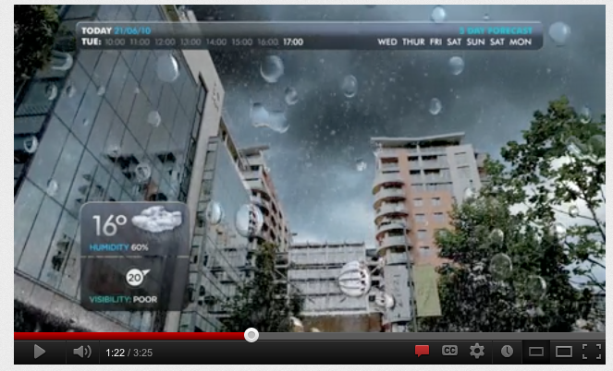

This video led me to a website called Hidden. They created the video and I have learned more from looking at the technology and projects they have on their site. I found that augmented reality could be used in many different ways. Some examples they had are for events, campaigns, and digital marketing. With digital marketing you can use augmented reality on a website to help make products more interact and appealing to customers. They will be able to see more of what the product looks like and be more wiling to buy it. Another thing that I have thought of from seeing the video is it could be used for architecture. It is a good way to visualize buildings in a location before they are built. Or it could be used for interior design. In the video on the future of augmented reality there was a segment on designing an office and being able to select different colors and decorate. 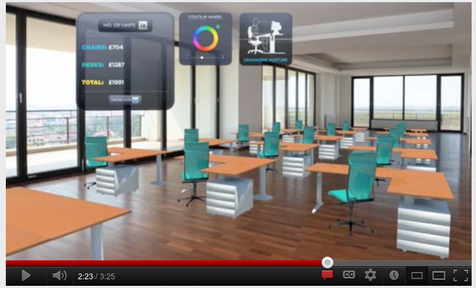

Augmented reality will be based off of using smartphones and tablets, by using a webcam to see surroundings. [5] Then you will just use an app to view the features of augmented reality. It is a pretty simple idea and will easily be able to be integrated into the technology world with the use of smartphones and tablets. The Interaction with daily surrounding will increase and be even better. “Users can interact with products and the world around them, personalizing their own experiences based on how they literally see the world.”[6] Therefore, with more interaction people will be able to personalize their experience more. Augmented reality will allow for people to make decisions on what they want to view and how they want to see the world.

There have been many different companies designing augmented reality glasses and going to court to get the patent for their design. Recently, Microsoft got a patent on their version of the glasses.

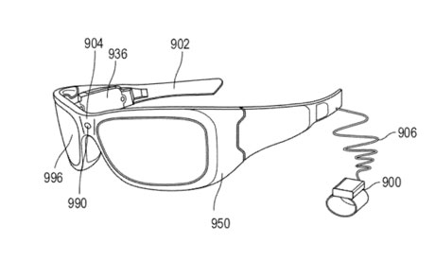

The glasses have been designed for live events. “Microsoft suggests that its AR glasses could add lyrics during a live performance.”[7] This would be good at an opera or concert. Being able to interact with the music and see the words can enhance the experience. “Microsoft says it would be able to offer instant replays directly through its AR glasses, as well as annotating what’s happening on the field.”[8] This would be good for sporting events, so that fans can re-watch something if they miss a play or want to see it again. The design of the glasses is also really convenient because they look like sunglasses and can be easily worn.

There are some problems with augmented reality, just like any other emerging technology. “Many augmented reality projects rely on specific or customized hardware, and the mechanisms that correlate data added by technology with the real world are often technically complex.”[9] This can be a problem because the technology should be understandable for the average user to be a successful product. Also, since specific hardware is needed it can be expensive to produce, which can lead to it being really expensive for consumers to get. There is also the issue of privacy. “With the rise of AR apps, combined with geotagging, there are going to be moments when you either reveal who you are, or where you are at exactly the most inopportune instant. And something will go wrong.”[10]

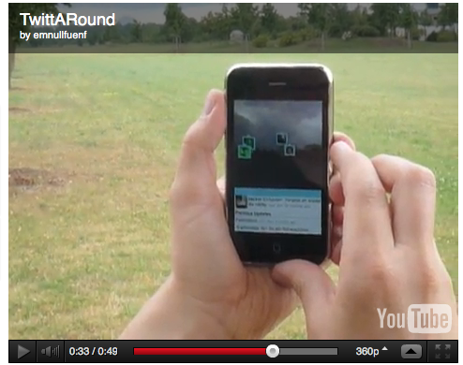

This can be a problem with social networking. The image above is showing how Twitter has a geotagging feature, which can lead twitter users tracking each other. And that can be unsafe since anyone can make a Twitter account. This could branch off into other social networking sites and be dangerous.

CONCLUSION

After researching and learning more about augmented reality I think that it will be important to our future. It will also play a major part in new media. With the ability to view information more interactively in the world, augmented reality will be of great interest in the future. Augmented reality can be used for so many different subjects and tasks in our daily lives. Most technologies are moving towards being more interactive and augmented reality is a big step in that direction.

REFERENCES

The Future of Augmented Reality. YouTube.

<http://www.youtube.com/watch?v=tnRJaHZH9lo>

Hidden: Augmented Reality

<http://www.hiddenltd.com/what-we-do/augmented-reality>

Augmented Reality Marketing Strategies: the how to guide for marketers. Hidden.

<http://www.hiddenltd.com/products/ar/Augmented-reality-marketing-strategies-the-how-to-guide-for-marketers__.pdf>

7 Things You Should Know About Augmented Reality. Educause Learning Initiative.

<http://net.educause.edu/ir/library/pdf/eli7007.pdf>

Arthur, Charles. Microsoft Gets Patent on Augmented Reality Glasses. The Guardian.

<http://www.guardian.co.uk/technology/2012/nov/27/microsoft-augmented-reality-glass-google-apple>

Eaton, Kit. Three Unexpected Dangers of Augmented Reality. Fast Company.

<http://www.fastcompany.com/1339617/three-unexpected-dangers-augmented-reality>

1. 7 Things You Should Know About Augmented Reality.
2. 7 Things You Should Know About Augmented Reality.
3. 7 Things You Should Know About Augmented Reality.
4. 7 Things You Should Know About Augmented Reality.
5. Hidden: Augmented Reality.
6. Hidden: Augmented Reality.
7. Microsoft Gets Patent on Augmented Reality Glasses.
8. Microsoft Gets Patent on Augmented Reality Glasses.
9. 7 Things You Should Know About Augmented Reality.
10. Three Unexpected Dangers of Augmented Reality.